**PURITY NDUMI MUSYIMI**

**REGISTATION NUMBER : SCII/04391P/2016**

**TECHNICAL UNIVERSITY OF KENYA**

**Due Date: 1stMARCH 2018**

**IBL 1 - Project**

NETWORK SCOPE

Assume you have been picked as the Computer/Data Network communication consultant, for a newly established University with no existing Network.

You are required to design a computer network for the individual campuses, as well as a wide area network, linking all campuses.

You are all required to provide cost effective internet Services to all campuses, to include all libraries, administration blocks, and LABs and Class/student internet service points.

*Note :The main server is at Nairobi campus,*

*: The university is expected to enrol, more students in coming years*

Below are details for the campuses

**Campus name and Location No. of students No of staff/lib and Admin**

a) Nairobi 300 80

b) Mombasa 200 70

c) Kisumu 150 35

**With the above details come up with the best design proposal that should include**

1. Campus LAN network, and WAN Topology for the entire university



Campus networks should leverage the following common set of engineering and architectural principles:

■ Hierarchy

■ Modularity

■ Resiliency

**Enterprise campus: Hierarchical design models**

The hierarchical network design model breaks the complex flat network into multiple smaller and more manageable networks. Each level or tier in the hierarchy is focused on a specific set of roles. This design approach offers network designers a high degree of flexibility to optimize and select the right network hardware, software, and features to perform specific roles for the different network layers.

A typical hierarchical enterprise campus network design includes the following three layers:

■ **Core layer:**Provides optimal transport between sites and high-performance routing. Due the criticality of the core layer, the design principles of the core should provide an appropriate level of resilience that offers the ability to recover quickly and smoothly after any network failure event with the core block.

■ **Distribution layer:**Provides policy-based connectivity and boundary control between the access and core layers.

■ **Access layer:**Provides workgroup/user access to the network. The two primary and common hierarchical design architectures of enterprise campus networks are the three-tier and two-tier layers models.

**Three-tier model**

This design model, illustrated in Figure 3-1 , is typically used in large enterprise campus networks, which are constructed of multiple functional distribution layer blocks

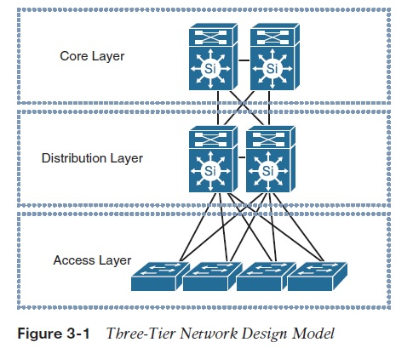

**Two-tier model**

This design model, illustrated in Figure 3-2 , is more suitable for small to medium-size campus networks (ideally not more than three functional disruption blocks to be interconnected), where the core and distribution functions can be combined into one layer, also known as collapsed core-distribution architecture .

**Note:**The term functional distribution block refers to any block in the campus network that has its own distribution layer such as user access block, WAN block, or data center block.

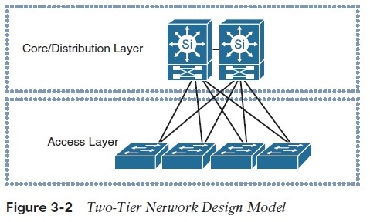

**Enterprise campus: modularity**

By applying the hierarchical design model across the multiple functional blocks of the enterprise campus network, a more scalable and modular campus architecture (commonly referred to as building blocks ) can be achieved. This modular enterprise campus architecture offers a high level of design flexibility that makes it more responsive to evolving business needs. As highlighted earlier in this book, modular design makes the network more scalable and manageable by promoting fault domain isolation and more deterministic traffic patterns. As a result, network changes and upgrades can be performed in a controlled and staged manner, allowing greater stability and flexibility in the maintenance and operation of the campus network. Figure 3-3 depicts a typical campus network along with the different functional modules as part of the modular enterprise architecture design.

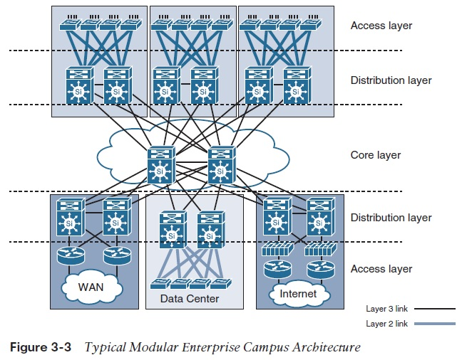

**Note:**Within each functional block of the modular enterprise architecture, to achieve the optimal structured design, you should apply the same hierarchal network design principle.

**When is the core block required?**

A separate core provides the capability to scale the size of the enterprise campus network in a structured fashion that minimizes overall complexity when the size of the network grows (multiple campus distribution blocks) and the number of interconnections tying the multiple enterprise campus functional blocks increases significantly (typically leads to physical and control plane complexities), as exemplified in Figure 3-4 . In other words, not every design requires a separate core.

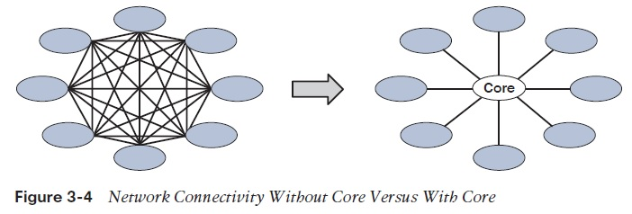

1. Come up with detailed design document listing the Items/Gadgets required for the LAN, WAN and all other associated items

A campus network is a proprietary local area network ([LAN](http://searchnetworking.techtarget.com/definition/local-area-network-LAN)) or set of interconnected LANs serving a corporation, government agency, university, or similar organization. In this context, a typical campus encompasses a set of buildings in close proximity. The end users in a campus network may be dispersed more widely (in a geographical sense) than in a single LAN, but they are usually not as scattered as they would be in a wide area network ([WAN](http://searchenterprisewan.techtarget.com/definition/WAN)).

College and university campus networks interconnect administrative buildings, residence halls, academic halls, libraries, student centers, athletic facilities, and other buildings associated with the institution in a specific town or neighborhood. Corporate campus networks interconnect buildings that house key departments and staff members. The corporate campus network forms the user-facing aspect of the larger corporate network within a limited geographic area.

In the ideal case, all of the [nodes](http://searchnetworking.techtarget.com/definition/node) in a campus network are interconnected by means of [optical fiber](http://searchtelecom.techtarget.com/definition/optical-fiber) media, taking advantage of [Gigabit Ethernet](http://searchnetworking.techtarget.com/definition/Gigabit-Ethernet) or [10-Gigabit Ethernet](http://searchnetworking.techtarget.com/definition/10-Gigabit-Ethernet) technology. In some cases, [Wi-Fi](http://searchmobilecomputing.techtarget.com/definition/Wi-Fi) [hot spots](http://searchmobilecomputing.techtarget.com/definition/hot-spot) or even a [hot zone](http://searchmobilecomputing.techtarget.com/definition/hot-zone) make up the user end of the network, for example in university student centers or libraries where numerous people simultaneously use portable and mobile devices such as [notebook](http://searchmobilecomputing.techtarget.com/definition/notebook-computer) and [tablet](http://searchmobilecomputing.techtarget.com/definition/tablet-PC) computers to conduct research and carry on communications.

**Apart from the computers, and other devices like printers and faxes, a LAN has to have six essential components to function.**

1. Network Adapter. A computer needs a network adapter to connect to a network. ...
2. Network Medium. Wired networks need cable. ...
3. Cable Connectors. ...
4. Power Supply. ...
5. Hub/Switch/Router. ...
6. Network Software
7. **Justify (ii) above and probable brands to use that are readily available in the local market**

Cisco is best because of compatibility

1. **State IP addresses to use, for LANs and WANS**

LAN and WAN as 2 sides of a gateway device. routers, modems, firewalls, for example are gateway devices. the WAN side faces the outside, the cloud, the internet. The LAN side faces the local area network.   
  
1. they have different IP address because they have different functions.  
2. they can be private or public, usually WAN is public and LAN is private  
3. with most consumer grade devices you don't have to specify the WAN (public) IP. you just need port number and internal (private) IP address.  
bonus answer: you can forward ports to only one internal IP address. forwarding port 80 to 2 internal IPs is not possible.

1. **Propose the best computer server specifications,**

ERVER 1  
____________________________________________________________  
HP DL385G7 SFF CTO Chassis  
HP 6134 DL385G7 FIO Kit  
HP 6134 DL385G7 Kit  
HP 4GB 1Rx4 PC3-10600R-9 Kit  
HP 450GB 6G SAS 10K 2.5in DP ENT HDD  
HP 146GB 6G SAS 15K 2.5in DP ENT HDD  
HP HH SATA DVD ROM Kit  
HP 512MB P-Series BBWC Upgrade  
HP 750W CS Gold Ht Plg Pwr Supply Kit  
____________________________________________________________

SERVER 2  
____________________________________________________________  
HP ML350R06 SFF CTO Chassis  
HP E5630 ML350 G6 FIO Kit  
HP E5630 ML350 G6 Kit  
HP 4GB 1Rx4 PC3-10600R-9 Kit  
HP 450GB 6G SAS 10K 2.5in DP ENT HDD  
HP 146GB 6G SAS 15K 2.5in DP ENT HDD  
HP HH SATA DVD ROM Kit  
HP 512MB P-Series BBWC Upgrade  
HP 750W CS Gold Ht Plg Pwr Supply Kit  
____________________________________________________________  
  
  
SERVER 3   
____________________________________________________________  
IBM x3650 M3 Rackmount Server  
1 x Xeon 4C E5620 80W 2.40GHz/1066MHz/12MB  
16GB (4 x 4GB, 2Rx4, 1.5V) PC3-10600 CL9 ECC DDR3 1333MHz LP RDIMM  
2 x IBM 146 GB 2.5in SFF Slim-HS 10K 6Gbps SAS HDD (in RAID 1)  
4 x IBM 500GB 7.2K NL SATA 2.5-inch SFF Slim-HS HDD (in RAID 5)  
1 x IBM ServeRaid SR M5014 controller  
1 x Multi-Burner DVD drive  
2 x 675W Redundant AC Power Supplies

1. **Propose the best storage devices for the expanding university.**

Cloud storage

External ssd Hard disk

A planned and routine back up of its data

1. **Indicate how back up and disaster recovery will be handled**

## using virtual machines is the scope for improved backup

Virtualisation changes everything and increases the number of options. First, data can be easily backed-up as part of an image of a given virtual machine (VM), including application software, local data, settings and memory. Second, there is no need for a physical server rebuild; the VM can be recreated in any other compatible virtual environment. This may be spare in-house capacity or acquired from a third-party cloud service provider. This means most of the costs of redundant systems disappear.

Disaster recovery is cheaper, quicker, easier and more complete in a virtual world. In the idiom of backup, faster recovery time objectives (RTOs) are easier to achieve. At least, that is the theory, but it can get more complicated with the need to co-ordinate different VMs that rely on each other – for example an application VM and a database VM – so testing recovery is still paramount and can forestall problems in live systems.

1. **Propose how network security will be enforced, and where hardware devices to assist on the same will be placed.**

**Use of NIC cards and firewall for enforcement** … From a security standpoint, the pieces of hardware that will help provide security are firewalls and routers. Firewalls come in two varieties: hardware and software. You can purchase a physical firewall device or run a firewall application. Many routers have firewall software built into them.

Firewalls act like filters. They help you monitor data traffic between your network and the Internet. If you detect unusual traffic, that's a potential sign that someone has compromised your home network's security. Most firewalls have several security settings to choose from. The most restrictive settings are generally the safest, but they also limit your options. Most firewalls will allow you to create a list of Web addresses that are off limits.

1. **Given the distant locations of the campuses, how and which transmission media would be the best to link them and why**

**Fibre with a VPN…** Fiber optic cable has bandwidth more than **2 gbps (Gigabytes per Second)**

* Capable of extremely high speed
* Extremely low attenuation
* No EMI interference

**Advantages Of Fiber Optic Cable:**

* Fast
* Low attenuation
* No EMI interference

1. **Come up with the probable estimate budget to implement the project**

|  |  |  |
| --- | --- | --- |
| **Proposed VLAN for Campus Network** | | |
| **Sl** | **VLAN ID** | **VLAN Name** |
| 1 | 10 | Student |
| 2 | 15 | Faculty |
| 3 | 20 | Admin |
| 4 | 25 | Computer Lab |
| 5 | 30 | Exam |
| 6 | 35 | Accounts |
| 7 | 40 | Internal Servers |

|  |  |  |
| --- | --- | --- |
| **ITEM** | **NO** | **COST** |
| SERVERS | 40 | 1000000 |
| COMPUTER LABS | 25 | 5000000 |
| CABLING |  | 500000 |
| ISP | PER MONTH | 500000 |
| SWITCHES | 20 | 2000000 |